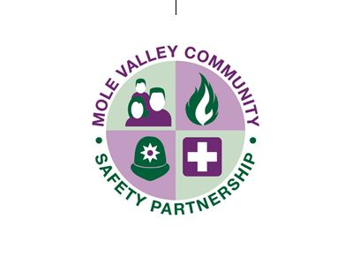


Safeguarding Adults Review

‘Simon’

Publication Statement

The Surrey Safeguarding Adults Board (SSAB) and Mole Valley Community Safety Partnership (MVCSP) have today published the findings of a joint Safeguarding Adult Review (SAR)/Domestic Homicide Review (DHR) in relation to Simon.

On behalf of the board and the Partnership, we would like to offer our deepest sympathies to the family following the tragic loss of Simon.
This review was jointly commissioned to ensure that there was an independent oversight of the circumstances surrounding the death of Simon. The review does not seek to apportion blame but to consider the way agencies worked together to support Simon and to look at what lessons can be learned to assist those facing similar situations in the future.

As well as highlighting areas of good practice, the review identified important learning and key areas for further improvement both locally and nationally.

We fully accept the findings of the review which examined the role of agencies before and after Simon’s death. The review found that there were missed opportunities, which included the need for better communications across all agencies in order to support Simon.
We are reassured that agencies have taken steps to address much of the learning from the events of Simon’s life. We have shared the review with all relevant agencies and will hold them to account in making sure the recommendations are acted on.

Teresa Bell,
Independent Chair
Surrey Safeguarding Adults Board
July 2025

Rachel O’Reilly
Chair
Mole Valley Community Safety Partnership
July 2025

